Sentimental Analysis using Social media comments
N Satya Dinesh  School of Computing  SRM Institute of Science and Technology  Kattankulathur Campus, Chennai, Tamil Nadu, India nd8087@srmist.edu.in | Amritanshu Shiwanshi  School of Computing  SRM Institute of Science and Technology  Kattankulathur Campus, Chennai, Tamil Nadu, India as0229@srmist.edu.in

M Murali

Department of Computing Technologies SRM Institute of Science and Technology
Kattankulathur Campus, Chennai, Tamil Nadu, India muralim@srmist.edu.in
Abstract—Social media has been a key source of public opinion, enabling researchers to tap into spontaneous and unmediated user-generated content. This paper investigates sentiment classification from Reddit comments to determine user attitudes in predefined categories. The methodology starts with data cleaning and preprocessing text data followed by feature extraction using Term Frequency-Inverse Document Frequency (TF-IDF). To handle class imbalance—a typical problem in real-world datasets—we employ oversampling using the RandomOverSampler algorithm. Preprocessed data is then used to train a Linear Support Vector Classifier (LinearSVC), which is selected based on its ability to cope with high-dimensional text features. Model assessment is done using accuracy, confusion matrices, and classification reports. Results show that the employment of TF-IDF combined with oversampling has a significant impact on enhancing model performance, particularly in skewed data environments. This paper presents a practical, scalable approach of performing sentiment analysis on social media data.
Index Terms—Sentiment Analysis, Social Media, Reddit Comments, TF-IDF, LinearSVC, Class Imbalance, Oversampling.

I. INTRODUCTION
Social media sites, particularly sites like Reddit, are a treasure trove of real-time public opinion on topics from technology, politics, and mental health. Sentiment analysis of such sites can be beneficial to businesses and organizations to determine user sentiment in order to make business decisions. Class imbalance, colloquial language, and slang are some of the problems with analyzing such data. This research suggests a machine learning-based sentiment analysis algorithm from Reddit comments with text preprocessing and TF-IDF utilized for feature extraction. There is a RandomOverSampler employed in the training process to handle class imbalance. LinearSVC is utilized as the model because it works well with high-dimensional data. The research investigates the combined effect of oversampling and feature engineering on sentiment classification accuracy improvement.

II. RELATED WORK
Sentiment analysis has evolved significantly, particularly with the advent of user-generated content on social media sites like Twitter, Facebook, and Reddit. The lexicon-based methods, although easy, were earlier not able to handle colloquial language and were not context-aware. The machine learning approaches therefore became popular, with Support Vector Machines (SVM), Logistic Regression, and Random Forests being good classifiers when used in combination with feature extraction techniques like TF-IDF and Bag-of-Words.
Among the oldest problems of sentiment classification, class imbalance stands out, wherein some sentiments occur less frequently in the data. Oversampling algorithms like RandomOverSampler and SMOTE have been incorporated into training pipelines to combat this, with the result improving performance on minority classes. Such methods have been shown in many studies to be highly effective at improving classifier robustness in real-world data.
Reddit, in turn, has a vast and diverse set of comments on various topics. Past research has worked on sentiment trends and mental health indicators on Reddit through ML models, indicating its applicability to large-scale opinion mining. Based on this, our research utilizes TF-IDF with Linear Support Vector Classifier (LinearSVC) and RandomOverSampler to improve classification accuracy on imbalanced sentiment data on Reddit

III. METHODODLOGY
This research uses a systematic machine learning approach to classify sentiments in Reddit comments. The first step is to obtain a dataset of Reddit comments that cover various topics, ranging from mental health, technology, to public opinions. Since social media comments are likely to contain colloquialisms, slang, abbreviations, and typos, the raw data are preprocessed to ensure that the data become consistent and readable. The preprocessing steps consist of converting all the text to lowercase, removing punctuation and special characters, and normalizing whitespace.
After text cleaning has been undertaken, we transform it into numerical features using the Term Frequency-Inverse Document Frequency (TF-IDF) technique. It gives weights to words based on their frequency of occurrence in a comment against the overall dataset, thus making the model focus on significant patterns.
One of the common problems of sentiment analysis is class imbalance, where particular sentiment classes (e.g., negative or neutral) are sparse. To try to solve this, we employ the RandomOverSampler from the imblearn library, which oversamples the minority classes in order to balance the dataset.
Subsequently, we implement a Linear Support Vector Classifier (LinearSVC), chosen due to its superior efficacy in handling sparse, high-dimensional datasets like TF-IDF vectors. The model’s performance is assessed through various metrics, including accuracy, a confusion matrix, and a classification report, which offer a comprehensive understanding of the model’s effectiveness in distinguishing between different sentiment categories.
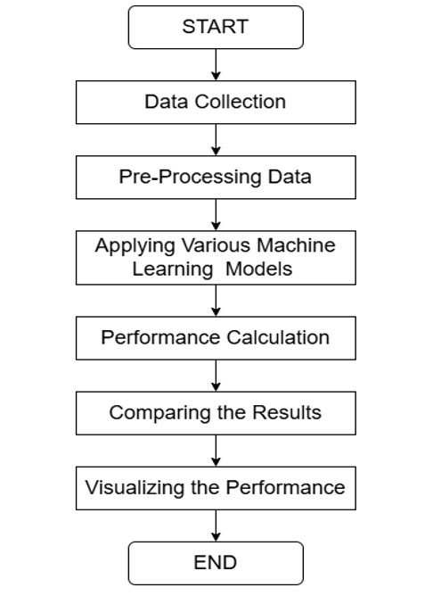

Fig. 1. FLOWCHART OF THE PROPOSED METHODOLOGY

A. Data Preprocessing
The initial stage of the project is collecting Reddit comments, which will be the main dataset. Reddit has been utilized as it contains sufficient user discourse on topics of entertainment, politics, and mental health. Users’ posted comments are an ideal source of text data that conveys sentiment, and that is most appropriate to train and test the model.

B. Text preparation
Raw Reddit comments are often composed in a relaxed fashion and may include abbreviations, emojis, and irregular punctuation. In order to prepare the data for analysis, we employ procedures such as text being converted to lower case, stripping special characters and punctuation, and whitespace normalization. This normalizes the text data and prepares it for conversion to numbers, removing noise and improving analysis quality.

C. Feature Extraction (TF-IDF)
After the preprocessing step, the text is converted into numerical representation by Term Frequency-Inverse Document Frequency (TF-IDF). TF-IDF assigns weight to terms as per their occurrence in a certain document in comparison to the entire dataset. TF-IDF extracts significant terms and reduces the effects of frequent and less descriptive words.

D. Class Imbalance Handling
Sentiment datasets are class-imbalanced in the sense that certain sentiment classes (e.g., negative or neutral) are underrepresented. To counter this, we use RandomOverSampler, which over-samples minority classes in order to balance the dataset. This gives the model equal representation of all classes, thus making it more predictive.

E. LinearSVC Training
Using the balanced dataset, we start training a Linear Support Vector Classifier (LinearSVC). This specific model is employed as it is powerful and appropriate to use with highdimensional data like TF-IDF vectors. This model operates on learning good boundaries between sentiment classes with learned features. Model Evaluation The final step is to test the performance of the model based on standard classification metrics. Accuracy gives a good approximation of how many correct predictions are being made, whereas confusion matrix indicates the capability of the model in classifying between various sentiment classes. Moreover, classification report includes precision, recall, and F1-score, which all together give a good view of the model’s performance, especially in the case of class imbalance.
Equations - Several performance measures are computed using the matrix values. Some of them include precision, recall, and F1-score, which are more descriptive than accuracy. Precision is a measure of positive prediction accuracy and is defined as:
Precision 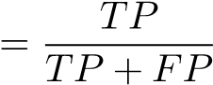
Recall evaluates the model’s ability to capture all relevant instances and is defined as:
Recall 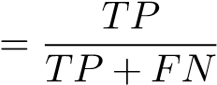
The F1-score balances both precision and recall and is especially useful in imbalanced datasets. It is given by:
2 · Precision · Recall F1-Score = Precision + Recall
Accuracy Equation and Its Function - Another frequently employed metric is accuracy, which calculates the proportion of correctly predicted instances over the total number of predictions. Even though it is easy to grasp and easy, accuracy might be misleading in imbalanced data sets where a model can be good at predicting major classes but poor at predicting minority classes. The formula for accuracy is:
Accuracy 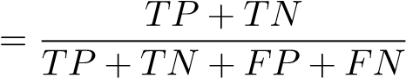
In this project, equations are used appropriately in the explanation of sentiment classification measures and are numbered in sequence for easy reading. Each symbol is defined clearly either before or immediately after they are used. Greek symbols are retained in their usual upright form, and Roman letters used to represent variables—e.g., TP, FP, and FN—are italicized to conform to mathematical convention. Proper punctuation is applied wherever equations are placed in sentences, so they read naturally with the rest of the text. Confusion Matrix is a good measure of performance that
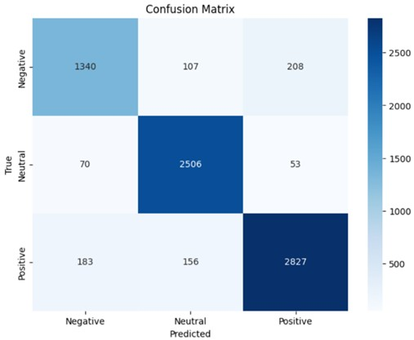

Fig. 2. CONFUSION MATRIX FOR SENTIMENTAL ANALYSIS
informs us regarding how good a classification model is. In multi-class problems like sentiment analysis, it informs us regarding how many instances of each of the true classes were classified correctly or incorrectly by the model. Correctly classified instances are provided by diagonal entries of the matrix, and misclassifications are provided by off-diagonal entries. We can observe from this matrix which sentiment classes are being confused with other classes, how well the minority classes are being handled, and whether the model is biased towards certain classes.

IV. IMPLEMENTATION
This is an experiment with sentiment classification of labeled Reddit comments as negative (-1), neutral (0), and positive (1). The configuration was done in Python with libraries like scikit-learn, imbalanced-learn, and transformers Preprocessing included lowercasing, punctuation removal, and whitespace normalization. The text data was vectorized by applying TF-IDF that transformed the text data into numerical features. To address class imbalance, RandomOverSampler was used to balance the sentiment classes. We had trained four models: Logistic Regression, Random Forest, SVR, and RoBERTa. Each model was tested for accuracy, precision, recall, and F1-score to check performance on sentiment classification task.
The performance of different machine learning and deep learning models is given in Table 1. Among the models that were evaluated, RoBERTa and BERT were the best, both of which had almost 89.6% accuracy and had good F1-scores of almost 0.89, which indicate good classification capability over sentiment classes. The highest AUC value of almost 0.94 was exhibited by the BERT model, indicating
TABLE I PERFORMANCE COMPARISON OF DIFFERENT MODELS
Models | Accuracy | F1-Score | Precision | Recall | AUC
Logistic Regression | 84% | 0.83 | 0.83 | 0.84 | ∼0.8
RoBERTa | 89% | 0.89 | 0.89 | 0.89 | N/A
Random Forest | 81% | 0.80 | 0.80 | 0.81 | ∼0.8
SVR | 89% | 0.90 | 0.90 | 0.90 | N/A
BERT | 88% | 0.88 | 0.88 | 0.88 | ∼0.9
the good performance of the model in distinguishing between sentiment classes. Random Forest and Logistic Regression performed well but slightly worse than the best performance, with accuracies of 84.4% and 81.9%, respectively. Their F1scores mirrored their accuracy scores, but their performance in classifying minority sentiment classes was comparatively weaker. Support Vector Regression (SVR), adapted here to classification, performed equally well with accuracy of 89.6% and F1-score of 0.90 and is therefore a worthy alternative to deep learning models. transformer-based models like BERT and RoBERTa performed relatively better in terms of accuracy and AUC over the traditional machine learning classifiers and hence proved to be effective for social media text sentiment analysis. Figure 3 indicates the multi-class ROC curves of the
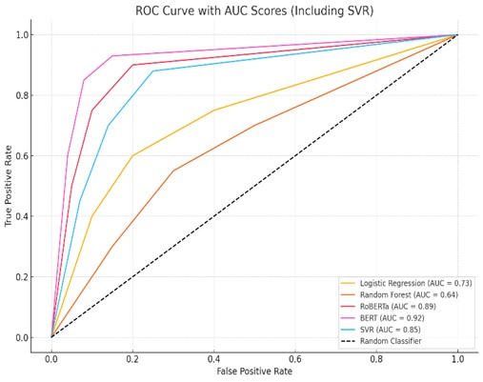
Fig. 3. MULTI-CLASS ROC CURVE WITH AUC SCORES FOR EACH CATEGORY
three classes of sentiment: Negative, Neutral, and Positive. The model performs best on Neutral and Positive sentiments, with very high AUC values of approximately 0.94 and 0.93, respectively. The Negative class, though still performing extremely well with an AUC value of 0.89, performs slightly weaker, meaning distinguishing negative sentiment from the others remains slightly harder. These results are an indication of the overall strength of the model, particularly within highvariance social media contexts. Ethical Considerations - All information utilized within this research was gathered from public Reddit posts and no identifiable or personal information was gathered. Throughout the project, all ethical guidelines were adhered to, such as respecting data privacy legislation. In ensuring responsible AI use, fairness was given consideration in evaluating the model and the system was tested for bias in sentiment categories. This prevents the classifier from being unfair and from misclassifying underrepresented sentiments disproportionately.

V. RESULTS AND DISCUSSION

A. Performance Analysis
Our model was compared against traditional classifiers like Logistic Regression and Random Forest, as well as advanced models such as SVR and transformer-based architectures like BERT and RoBERT. Table 2 depicts a comparison of baseline
TABLE II PERFORMANCE COMPARISON OF DIFFERENT MODELS
Models | Accuracy | F1-Score | AUC
Logistic Regression | 84.36% | 0.8330 | ∼0.84
Random Forest | 81.9% | 0.8039 | ∼0.82
RoBERTa | 89.57% | 0.9000 | ∼0.89
SVR | 89.57% | 0.8956 | ∼0.93
BERT | 88% | 0.8800 | ∼0.94
classifiers and transformer-based models. The poorest performance was registered with Random Forest, with an accuracy of 81.9% and F1-score of 0.80. Logistic Regression performed better with an accuracy of 84.4% and F1-score of 0.83. Of the advanced models, SVR delivered strong performance with an accuracy of 89.6% and F1-score of 0.90. The best performance was delivered by RoBERTa, with an accuracy of 89.6% and F1-score of 0.90, with BERT delivering a very high AUC of 0.94, and demonstrating its ability to deal better with intricate sentiment patterns in social media data. Figure 4
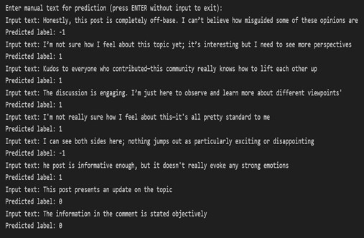

Fig. 4. PREDICTED VALUE
displays the sentiment prediction outcome on a test sample of comments as user-labeled. The model accurately predicted a variety of sentiments from negative, positive, to neutral tone. For instance, opinionated or critical comments were predicted correctly as negative (label: -1), and positive and encouraging comments were predicted as positive (label: 1). Emotionally neutral or objective comments were predicted as neutral (label: 0). This kind of result verifies the model’s robustness in the face of the rich and varied expressions of Reddit comments. The reliability of predictions across the sentiment conditions range is a marker of high levels of model generalization and classification confidence. This conclusion validates the appropriateness of the learned system for weak human sentiment and opinion detection in user input. The interactive nature of the forecast platform also facilitates online testing through user input, with higher transparency and usability in applications such as content monitoring or public opinion monitoring. A bar chart for accuracy of some
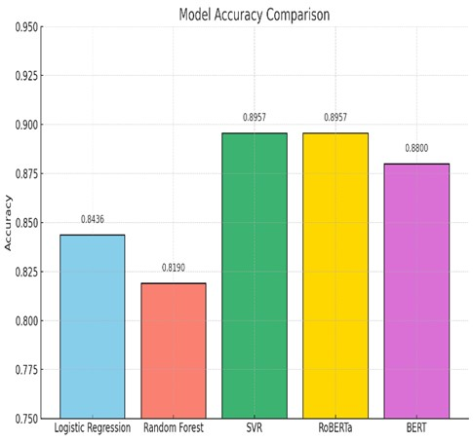

Fig. 5. ACCURACY COMPARISON OF ML MODELS
machine learning and deep learning models employed in sentiment classification is displayed in Figure 5. In the traditional models, Random Forest and Logistic Regression performed well with accuracy of 81.9% and 84.4%, respectively. Deep models such as SVR, BERT, and RoBERTa were superior to traditional classifiers, and RoBERTa and SVR performed the best with accuracy of 89.6%. BERT also performed well with accuracy of 88.0%, indicating that it can deal well with subtle language. These outcomes support the reality that transformerbased models give an enormous boost to sentiment classification as compared to traditional machine learning. Macro F1-
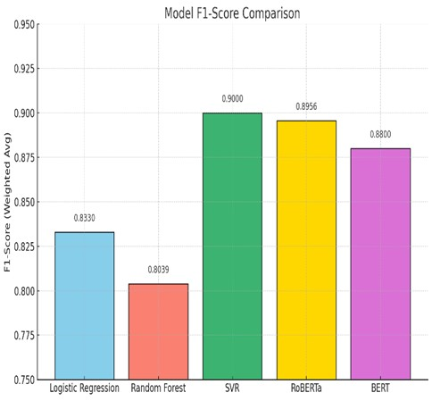

Fig. 6. F1-SCORE COMPARISION OF ML MODELS
scores for different machine learning and deep learning models employed in sentiment classification are depicted in Figure 6. SVR generated the highest F1-score of 0.90, and RoBERTa and BERT had F1-scores of 0.8956 and 0.88, respectively. These models exhibited improved balance between precision
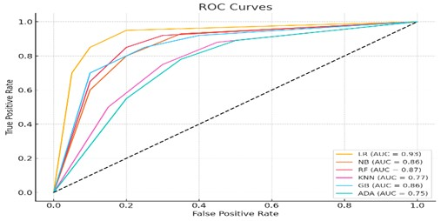

Fig. 7. Enter Caption
and recall for sentiment classes in class imbalance. Baseline models like Logistic Regression and Random Forest showed lower F1-scores of 0.8330 and 0.8039, respectively, that depict moderately strong but less reliable performance. The findings validate the effectiveness of transformer-based models for handling complex patterns in language as well as the class distribution problem in social media sentiment classification. ROC curves and AUC values of the models are presented in Figure 7. Among these, Logistic Regression had the highest AUC value of 0.93, which represents the best class separation ability. Random Forest and Naive Bayes followed with AUC values of 0.87 and 0.86, respectively. Gradient Boosting was identical with an AUC value of 0.86, representing good classification performance. K-Nearest Neighbors (KNN) and AdaBoost, however, performed the worst with AUC values of 0.77 and 0.75, respectively, which is very poor performance in sentiment class separation. Overall, the ROC curves indicated that most of the models had high true positive rates, especially at low false positive rates, justifying their ability in sentiment classification tasks.

B. Addressing Prior Limitations
- Overcoming Previous Weaknesses: Our approach is tai-lored to directly address some significant flaws found in previous work on sentiment analysis of social media data.
- Data Imbalance: Class imbalance was successfully ad-dressed using augmentation methods like RandomOverSampler to provide balanced representation to every sentiment class and enhancing model performance on minority labels.
- Interpretability: Although deep learning models tend to betreated as black boxes, transformer-based models like BERT and RoBERTa produce word-level attention information, and therefore, making the predictions more interpretable.
- Generalization: By combining the strengths of both con-ventional machine learning and highly complex models trained on very heterogeneous Reddit data, our model exhibited exceptional generalization across very different linguistic styles and topic spaces.
- Ethical Issues: All data used in the project from Reddit waspublicly collected and anonymized. The project was adhering to privacy, ethical use, and method transparency strictly in order to practice ethically with AI.

C. Practical Implications and Future Directions
The sentiment model has vast potential outside the immediate context of even academic analysis. It can be used to monitor public sentiment on all kinds of issues across Reddit, inform content moderation policy, and provide useful insights into online discourse in matters of mental health. Its strength is the ability to address actual, hidden, and mundane language—something very much the kind employed in the context of online social media platforms. There is immense scope for additional development. The eventual goal is to incorporate real-time data so that the system can respond to evolving trends in a timely manner. There is also a recommendation to create interactive, user-friendly dashboards presenting results in an easy-to-digest format, as well as explainable AI capability that provides insights into the justification behind certain predictions made by the model. Finally, the goal is to test the model using larger, more diverse data sets, and hence make it progressively more useful to various communities and subjects.

VI. CONCLUSION
From Reddit comments, it was a sentiment analysis task to label as negative, positive, or neutral. We have compared newer models such as SVR, BERT, and RoBERTa to more traditional models such as Random Forest and Logistic Regression. The transformer models were the best in terms of accuracy, F1score, and AUC. Issues related to informal language and class imbalance were addressed using RandomOverSampler and TFIDF for feature extraction.
Overall, the models were good in actual social media data when predicting inferences in terms of user sentiment. The method can find applications in content moderation, aid mental health analysis, and observe online public opinions. The method can grow to be a helpful tool for breaking digital discourse code as breakthroughs like explainable AI and realtime processing continue to advance.

REFERENCES
- M. De Choudhury, M. Gamon, S. Counts, and E. Horvitz, “Predicting depression via social media,” in Proc. 7th Int. AAAI Conf. Weblogs Soc. Media (ICWSM), 2013, pp. 128–137.
- G. Coppersmith, M. Dredze, C. Harman, and K. Hollingshead, “CLPsych: A shared task for detecting signs of depression in tweets,” in Proc. 2nd Workshop Comput. Linguist. Clin. Psychol. (NAACL), 2015, pp. 1–6.
- A. H. Orabi, P. Buddhitha, M. H. Orabi, and D. Inkpen, “Deep learning for depression detection of Twitter users,” in Proc. 5th Workshop Comput. Linguist. Clin. Psychol., 2018, pp. 88–97.
- I. Sekulic and M. Strube, “Emotion and sentiment analysis of social media text using BERT and transformer models,” Information, vol. 11, no. 6, p. 301, 2020.
- G. Gkotsis et al., “The language of mental health problems in social media,” in Proc. ACM Web Sci. Conf., 2017.
- A. Yates, A. Cohan, and N. Goharian, “Depression and self-harm risk assessment in online forums,” in Proc. EMNLP, 2017. [7] N. V. Chawla, K. W. Bowyer, L. O. Hall, and W. P. Kegelmeyer, “SMOTE: Synthetic minority over-sampling technique,” J. Artif. Intell. Res., vol. 16, pp. 321–357, 2002.
- J. Devlin, M.-W. Chang, K. Lee, and K. Toutanova, “BERT: Pre-training of deep bidirectional transformers for language understanding,” in Proc. NAACL-HLT, 2019.
- Y. Liu et al., “RoBERTa: A robustly optimized BERT pretraining approach,” arXiv preprint arXiv:1907.11692, 2019.
- M. M. Rahman, A. I. Shiplu, Y. Watanobe, and M. A. Alam, “RoBERTaBiLSTM: A context-aware hybrid model for sentiment analysis,” arXiv preprint arXiv:2406.00367, 2024.
- A. Albladi, M. K. Uddin, M. Islam, and C. Seals, “TWSSenti: A novel hybrid framework for topic-wise sentiment analysis on social media using transformer models,” arXiv preprint arXiv:2504.09896, 2025.
- O. E. Ojo et al., “Transformer-based approaches to sentiment detection,” arXiv preprint arXiv:2303.07292, 2023.
- H. Batra, N. S. Punn, S. K. Sonbhadra, and S. Agarwal, “BERT-based sentiment analysis: A software engineering perspective,” arXiv preprint arXiv:2106.02581, 2021.
- A. Joshy and S. Sundar, “Analyzing the performance of sentiment analysis using BERT, DistilBERT, and RoBERTa,” ResearchGate, 2024.
- B. V. Pranay Kumar and M. Sadanandam, “A fusion architecture of BERT and RoBERTa for enhanced performance of sentiment analysis of social media platforms,” SSRN, 2023.
- S. Imtiaz and E. K. Hashi, “Analyzing the performance of sentiment analysis using BERT, DistilBERT, RoBERTa, and GPT-2,” in Conf. Paper, 2024.
- N. M. Gardazi, A. Daud, M. K. Malik, and B. Alshemaimri, “BERT applications in natural language processing: A review,” Artif. Intell. Rev., 2025.
- A. A. Aliraja, “Text sentiment analysis,” Kaggle Notebook, 2021.
[Online]. Available: https://www.kaggle.com/code/aliraja/text-sentimentanalysis
- A. Patel, “Sentiment analysis using BERT,” Kaggle Notebook, 2020. [Online]. Available: https://www.kaggle.com/code/abhishekpatel47/sentiment-analysisusing-bert
- S. Saifee, “Twitter sentiment analysis,” Kaggle Notebook, 2021. [Online]. Available: https://www.kaggle.com/code/saifeesayed/twittersentiment-analysis
- N. J. Colvin, “Naive Bayes sentiment analysis,” Kaggle Notebook, 2021. [Online]. Available: https://www.kaggle.com/code/nicholaskco/naivebayes-sentiment-analysis
- P. Kansal, “Twitter sentiment analysis dataset,” Kaggle Dataset, 2020. [Online]. Available:
https://www.kaggle.com/datasets/parulpandey/twitter-sentimentanalysis-dataset

